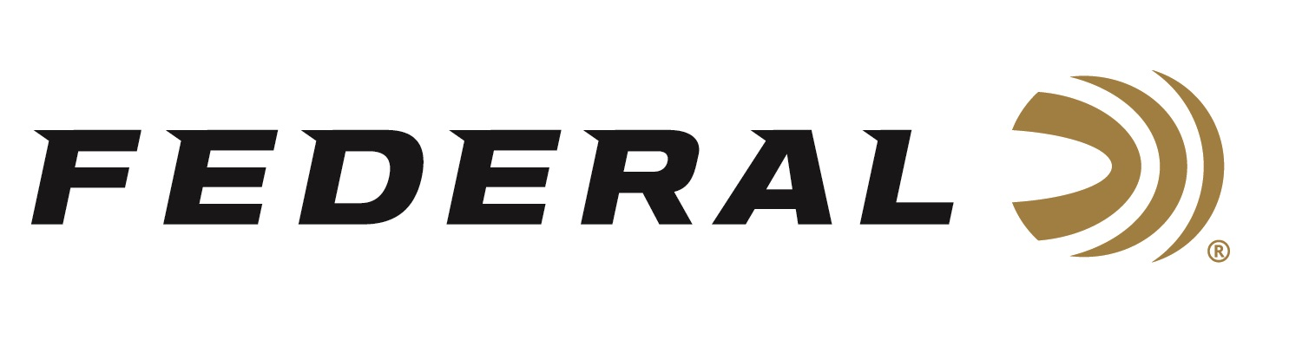

FOR IMMEDIATE RELEASE

Landing Gear Down on “It’s Federal Season” Podcast

ANOKA, Minnesota – September 15, 2022 – Chad Belding, host of The Fowl Life on Outdoor Channel, is the host of this episode of “It’s Federal Season” podcast. Belding is joined by Drew Keeth of Honey Brake Lodge in Louisiana and these two friends discuss a bunch of important topics as seasons are underway in North America.

“Drew Keeth is perhaps one of the best waterfowl guides in the United States,” says Chad Belding, television host. “At the world-famous Honey Brake Lodge, they run an operation that is second to none and Drew has amazing insights when it comes to selecting a lodge, being prepared for the season, blind etiquette, the basics on calling and go to items for the blind bag,” states Belding.

In the Tech Talk segment, Adam Moser, Federal’s Director of New Product Development discusses ammunition options waterfowl hunters have to bag more ducks including a new Bismuth offering from Federal. Whether your season has begun or is about to take flight, this podcast if for the waterfowl enthusiast wanting good information to apply the next time you are in the blind.

Episode #39 “Landing Gear Down”
https://www.federalpremium.com/this-is-federal/podcast/

For this episode, besides listening on the Federal Premium website or Talk North podcast network, you can also subscribe to Federal Ammunition’s YouTube channel (https://www.youtube.com/user/federalpremiumammo) and tune in for the discussion.

Federal Ammunition can be found at dealers nationwide or purchased online direct from Federal. For more information on all products from Federal or to shop online, visit www.federalpremium.com.

Press Release Contact: JJ Reich
Senior Manager – Press Relations
E-mail: VistaPressroom@VistaOutdoor.com

About Federal Ammunition
Federal, headquartered in Anoka, MN, is a brand of Vista Outdoor Inc., an outdoor sports and recreation company. From humble beginnings nestled among the lakes and woods of Minnesota, Federal Ammunition has evolved into one of the world's largest producers of sporting ammunition. Beginning in 1922, founding president, Charles L. Horn, paved the way for our success. Today, Federal carries on Horn's vision for quality products and service with the next generation of outdoorsmen and women. We maintain our position as experts in the science of ammunition production. Every day we manufacture products to enhance our customers' shooting experience while partnering with the conservation organizations that protect and support our outdoor heritage. We offer thousands of options in our Federal Premium and Federal® lines-it's what makes us the most complete ammunition company in the business and provides our customers with a choice no matter their pursuit.

